**SPINACH**

**---**

**Swarmed Parallel Interpreter for Numerical Analysis with Collaborative Hubs**

**Architectural Concept Document**

**Version 1.1**

**Yehong Wang**

**10/19/2009**

Table of Contents

1. Top-Level Data Flow Diagram 2

2. Swarm Architecture 3

3. Multiple Programs in One Swarm 4

4. Collaborations 5

4.1. Team work flow dependencies 5

4.2 Integration Schedules 5

4.2.1. Interpreter Front End Team 5

4.2.2. Interpreter Core Team 6

4.2.3. Swarm Computing Team 6

4.2.4. User Interface Team 6

4.2.5. Plotting Team 7

4.2.6. Test Team 7

# 1. Top-Level Data Flow Diagram

# :Diagrams:DFD.png

Figure - Data Flow Diagram

# 2. Swarm Architecture

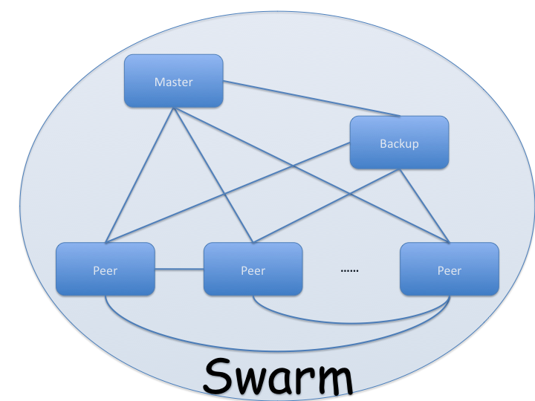

Figure - Swarm Architecture

In a swarm of multiple computers, there is always a master computer, a backup computer, and other peer computers. The master computer decides whom and how to distribute the parallelized works. Once any of the peers quits swarm intentionally or unintentionally, the master computer detect this and assign the work distributed to this computer to other computers in the swarm. If the disconnected computer happens to be the backup computer, besides re-assigning its work to others, the master computer also needs to anoint a new backup computer from all peer computers. If the master computer gets disconnected, the backup computer raises itself into the master computer, gives the backup computer role to another peer computer, and then assigns the work distributed to the previous master computer to other computers.

# 3. Multiple Programs in One Swarm

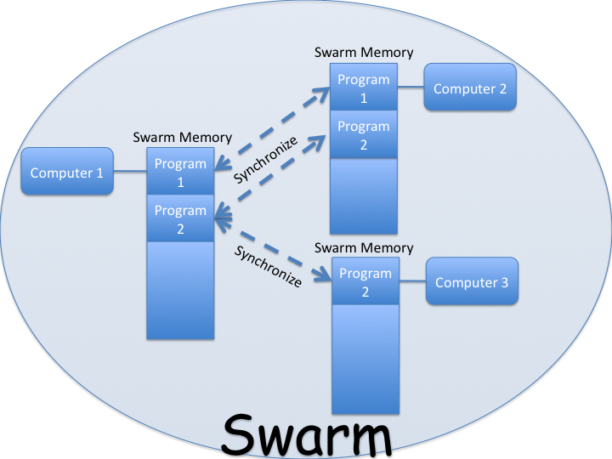

Figure - Multiple Programs in One Swarm

Each computer in the swarm has a part of swarm memory used particularly for swarm computing. When multiple programs run in the swarm, each program uses a chunk of swarm memory. This chunk of memory is synchronized among all peer computers having privileges to this program. Since different programs on one computer always use different chunk of memories, multiple programs is possible and should never interfere with one another.

# 4. Collaborations

## 4.1. Team work flow dependencies

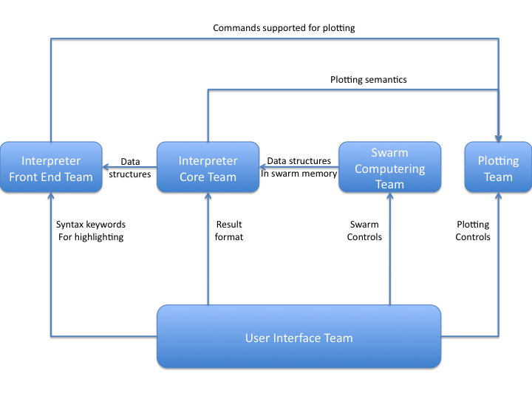

Figure - Team Work Flow Dependencies

## 4.2 Integration Schedules

### 4.2.1. Interpreter Front End Team

4.2.1.1. Interpreter Front End Team should start integration immediately after reviewing B Specification.

4.2.1.2. Interpreter Front End Team should notify User Interface Team about all SPINACH input syntax keywords to User Interface Team as soon as grammar file is made.

4.2.1.3. Interpreter Front End Team should design all acceptable element classes and abstract syntax tree class first. Once these classes have been declared Interpreter Front End Team should give Interpreter Core Team and Swarm Computing Team the prototypes.

### 4.2.2. Interpreter Core Team

4.2.2.1. Interpreter Core Team should start implementing execution of commands after receiving prototypes from Interpreter Front End Team.

4.2.2.2. Interpreter Core Team should design data structures stored in swarm memory and send prototypes to Swarm Computing Team once they are done.

4.2.2.3. Interpreter Core Team should design result format and send prototypes to User Interface Team once they are done.

4.2.2.4. Interpreter Core Team should finish all prototypes first before implementing features.

### 4.2.3. Swarm Computing Team

4.2.3.1. Swarm Computing Team should implement swarm built-up first, including network connection, sending data among peers, and granting privileges and transferring ownership of a program source code.

4.2.3.2. Swarm Computing Team should start implementing parallel execution as soon as receiving prototypes from Interpreter Front End Team and Interpreter Core Team.

4.2.3.3. Swarm Computing Team should communicate with User Interface Team about swarm controls as needed.

### 4.2.4. User Interface Team

4.2.4.1. User Interface Team should design interfaces to support all SPINACH features and communicate with different teams about different features as needed.

4.2.4.2. User Interface Team should communicate with Swarm Computing Team for the design of main interface.

4.2.4.3. User Interface Team should communicate with Interpreter Front End Team for the keyword set of SPINACH input syntax.

4.2.4.4. User Interface Team should communicate with Interpreter Core Team for the data format of execution results.

4.2.4.5. User Interface Team should communicate with Plotting Team for the design of plotting area in the program window.

### 4.2.5. Plotting Team

4.2.5.1. Plotting Team should decide what data sets to plot and how these data sets should be plotting when writing B Specifications.

4.2.5.2. Plotting Team should communicate with User Interface Team for plotting controls as needed.

### 4.2.6. Test Team

4.2.6.1. Test Team should start to design logo for SPINACH immediately.

4.2.6.2. Test Team should communicate with each team as needed while conducting Qualification Test.